South Salem Presbyterian Church
about 11 months ago
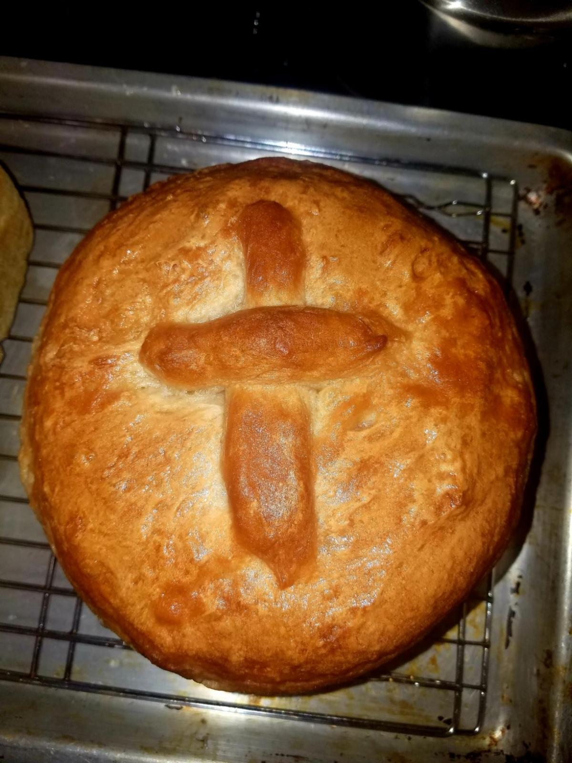
Robyn's Peasant Bread Recipe
We celebrate the Sacrament of Holy Communion each Sunday, Have your bread and wine/juice ready for the service.
Prep time 10 minutes
Inactive time 1.5 hours
Bake time 30 mins
Total time 2 hours approx
4 cups All purpose unbleached flour
2 tsp active dry yeast
2 tsp granulated sugar
2 tsp kosher salt
2 cups lukewarm water
Butter to prep baking dish and to brush the top of the loaf, approx half stick
Add sugar and yeast to lukewarm water, and set aside loop
Add 4 cups of sifted flour to a large glass or ceramic bowl along with the kosher salt
Pour water into the flour mixture and gently fold until water is completely absorbed.
Cover the bowl with plastic and set near the stove top, or somewhere slightly warmer than room temperature. (If you heat the oven to 350 and then turn off, this will create that little extra warmth to encourage the dough to rise.
Let the dough rise for one hour. It should expand to at least 3 or 4 times it's original size
Prep two baking dishes (either 7" diameter round or 9" loaf pan. Prep each one with non-stick spray or melted butter.
With two forks, pull the dough away from the edge of the bowl all the way around. Reach under the dough with the tines of the fork to completely lift away from the surface of the bowl, ideally turning the dough over on itself a few times
Next, with the forks, separate the dough into 2 equal parts. Drop one in each baking dish, cover and wait at least 30 minutes
Heat oven to 450. Remove cover and place baking dishes in the oven for 15 minutes. Have melted butter ready at the 15 minute mark. Remove and brush the top of each loaf with melted butter and return to the oven for 15 more minutes.
When the loaf easily separates from the pan, your bread is done. You may wish to bake an extra 2-3 minutes for crispy crust
Cool on a well spaced, well ventilated wire rack.
*if your oven space is smaller, your bake time might be shorter, and you may have to lower your temperature. Ex. I have a GE range and the 450 temp works great, but I've baked this bread in a French oven that has a much more enclosed space and had to turn the temp down to 400 to prevent the bread from burning.
Happy Baking! - Robyn Musicant

